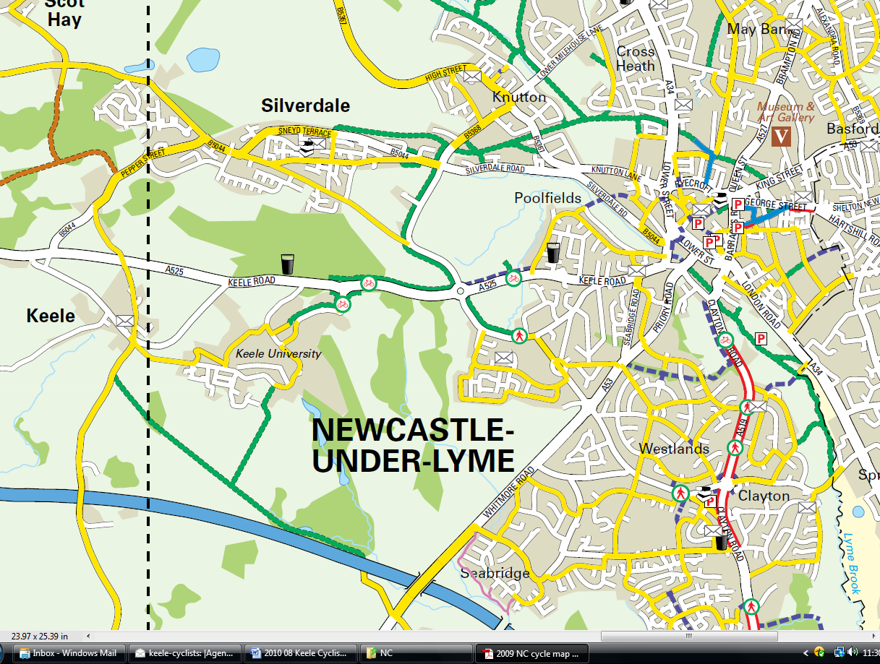
1
2
3A
4
5
3B
Cycle routes
1 To Newcastle town centre (via Orme Road)
2 To Newcastle town centre (via Silverdale Greenway)
3A To Hospital (via Lyme Valley)
3B To Hospital (via Westlands)
4 To Seabridge (via Lymes Road)
5 To Paris Avenue/Westlands (future route?)

